- Ibigereranyo muri Bibiliya:
  - Ibigereranyo ni iki?
    - Pawulo—n’abandi banditsi ba Bibiliya—bakoresha ijambo “ikigereranyo” bashaka kuvuga umuntu cyangwa ikintu cyo mu mateka gihagarariye ikintu cyangwa umuntu wo mu gihe cye cyangwa ahazaza (cyitwa “igishushanywa”).
    - Urugero, Abaroma 5:14 havuga kuri Adamu nk’ikigereranyo [“ishusho” muri ngeri ya Bibiliya yitiriwe umwami Yakobo] “cy’uwagombaga kuza,” ni ukuvuga Yesu—ushushanywa.
    - Kenshi na kenshi, dusanga mu Isezerano rya Kera ikimenyetso cy’uko abantu runaka cyangwa ibintu runaka ari ikigereranyo cy’ikintu cyajyaga kuza hanyuma. Mutyo turebe ingero ebyiri:
Ikigereranyo | Gutangaza ushushanywa | Ushushanywa
Dawidi (Zaburi ya 22:1) | Dawidi Mushya (Yeremiya 23:5) | Yesu (Matayo 27:46)
Ibitambo (Abalewi 1:3–5) | Kubabazwa k’umugaragu (Yesaya 53:5–7) | Urupfu rwa Yesu (Yohana 19:16–18)

  - Amoko y’ibigereranyo
    - Ibigereranyo byo mu Isezerano rya Kera bigaragaza ubwoko butatu butandukanye bw’ibishushanywa byo mu Isezerano Rishya: Kristo, Itorero, n’Ibihe by’Imperuka.
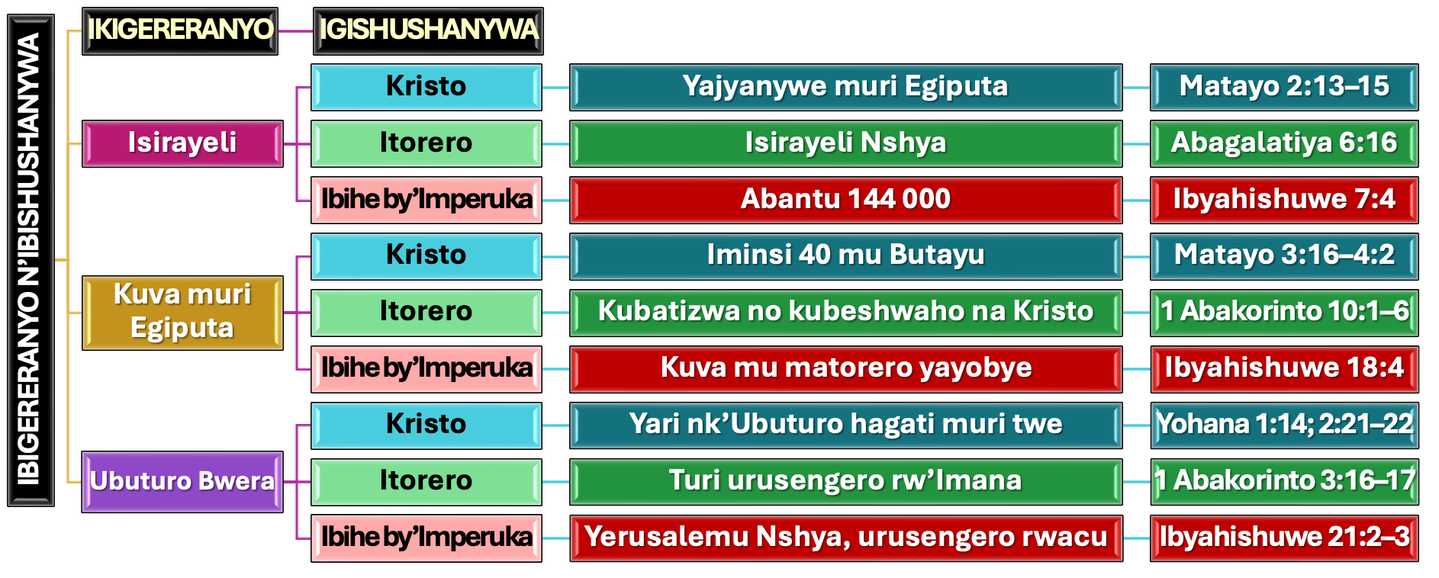

- Ibigereranyo bya Yosuwa:
  - Yosuwa nk’ikigereranyo
    - Yosuwa yasohoje umugabane w’ubuhanuzi bwa Mose buvuga umuhanuzi wa kabiri wajyaga kuyobora ubwoko (Gutegeka 18:15–19).
    - Kimwe na Mose, Yosuwa yahawe ubutumwa buvuye ku Mana; yizihije Pasika; yambutse amazi; yabonye Marayika w’Uwiteka; ukuboko kwe kurambuye kwazanye kunesha; yararikiye abantu gukomeza kuba indahemuka na nyuma y’urupfu rwe; n’ibindi.
    - Mu gihe manu yatangiye kugwa mu gihe cy’ubuyobozi bwa Mose, yahagaze mu cya Yosuwa. Ikindi, Yosuwa yashyize mu bikorwa amabwiriza Mose yari yaramuhaye yerekeye kugabana igihugu n’imidugudu y’ubuhungiro.
    - Ariko abantu basobanukiwe ko ubuhanuzi bwa Mose bwarenze Yosuwa (Yohana 1:21). Bityo, Mose na Yosuwa bombi bahinduka ibigereranyo by’Ushushanywa nyakuri wasohoje neza ubuhanuzi bwahawe Mose bwerekeye “Umuhanuzi”: Yesu (Ibyakozwe n’Intumwa 3:22–26).
  - Icyo Yosuwa agereranya
    - Intego y’intambara zayobowe na Yosuwa kwari ugutūza Abisirayeli mu Gihugu cy’Isezerano. Yesaya, akoresheje imvugo isa n’iyo mu gitabo cya Yosuwa, agaragaza umurimo wa Mesiya wo guha “abantu be gakondo ahari harabaye umwirare” (Yesaya 49:8).
    - Ni mu buhe buryo imibereho n’umurimo bya Yosuwa (nk’ikigereranyo) bigaragarira mu mibereho n’umurimo bya Yesu (ushushanywa)?
      - Nyuma yo kubatirizwa muri Yorodani, Yesu yarwanye n’imbaraga z’ikibi
      - Yatangiye umurimo We nyuma yo kumara iminsi 40 mu butayu
      - Yanesheje umwanzi ku musaraba
      - Aduha kunesha abanzi bacu bo mu bya mwuka
      - Aduha ihumure nyakuri
      - Aduha kuragwa gakondo itāngīrika
  - Yosuwa nk’ikigereranyo cy’Itorero
    - YOSUWA N’ITORERO
      - Uyu munsi dufite intambara tugomba kurwana, aho tuyobowe na “Yosuwa” wacu, uduha intwaro zikenewe (Abefeso 6:10–12).
      - Ikindi kandi, yamaze kuduha gakondo, kandi atwuzuza imigisha yo mu buryo bw’umwuka (Abefeso 1:3, 11).
    - YOSUWA N’IBIHE BY’IMPERUKA
      - Ariko gusohozwa kuzuye kwa Yosuwa kuzaba ku mperuka, ubwo ingabo zose z’ikibi zizarimbuka, maze tugafata gakondo yacu mu buryo bwuzuye: igihugu tuzaturamo dutunganiwe (Ibyahishuwe 20:7–9; Ezekiyeli 28:26).
      - Kugeza ubwo icyo gihe kizasohora, nimuze dukurire mu buntu nk’uko Yosuwa yabigenje, twemerere Imana kuduhindura kugira ngo buri munsi turusheho kumera nka Yo.

